Topic: Clarify "Westward intensification" shown in pp. 55R-56L. Since the description in the text is not clear enough, provide additional explanation/revision of the following words on the basis of your understanding.

Essay: Before the explanation of required words, I would like to briefly define the word called “westward intensification”. The westward intensification is a phenomenon that the currents are much stronger on the western than eastern side of ocean basins, which is shown as the followed figure.

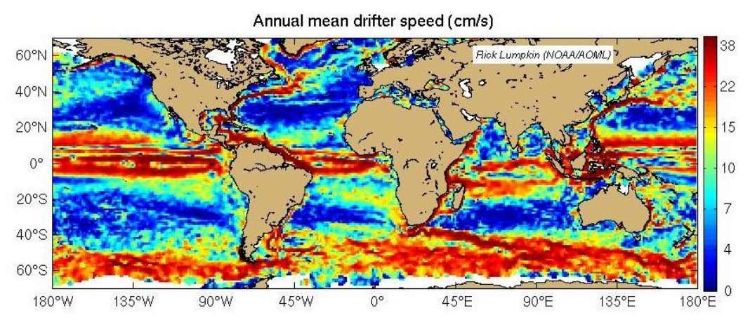

As we all known, the planet where we stay is rotating all the time. And according to the dynamics under a rotating coordinates, the velocity or the force can be divided into three parts: a rotating parts, a relative parts and a Coriolis parts. So we can imply that the Coriolis parameter is a value determines the Coriolis parts, which can be proved by the momentum equation as followed.

X momentum equation $-2 ω sinφ v= -f v$

Y momentum equation $-2 ω sinφ u= -f u$

In which, the Coriolis parameter is defined as twice the component of the earth's angular velocity about the local vertical, $2 ω sinφ$, where $ω$ is the angular speed of the earth and $φ$ is the latitude.

As a measure of parcels "spin", the vorticity can be divided into two primary sources of "vertical vorticity", planetary vorticity and relative vorticity, which are depended on these three elements, shear, curvature and Coriolis(or earth). So the planetary vorticity is generated by the rotating earth which belongs to Coriolis, and the relative vorticity is produced by shear and curvature.

Shear - A change in wind speed over some horizontal distance.

Curvature - A change in wind direction over some horizontal distance.

Coriolis - It is the spinning motion created by the Earth's rotation.

Here is a picture showed the difference between shear, curvature and Coriolis.

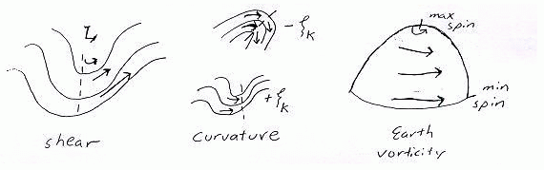

As the lecture materials said, there are three different types of currents includes the western boundary currents, the eastern boundary current and the transverse currents. And the westward intensification is caused by the difference between these currents.

Waters in western boundary currents typically move faster and these currents also extend much deeper than most other surface currents. Thus, the strong western boundary currents are so deep that they are deflected by the continental margins, which prevent these currents from flowing onto the shallow continental shelves. Eastern boundary currents are slower, shallower, and wider than the western boundary currents.

There are many factors affect the motion of current, such as the winds and Coriolis force. Take Coriolis effect as an example. Because Earth rotates, the shallow layer of surface water set in motion by the wind is deflected to the right of the wind direction in the Northern Hemisphere and to the left of the wind direction in the Southern Hemisphere. This deflection is known as the Coriolis effect. And it also leads the vorticity increases and reduces.

In other words, western intensification is the intensification of the western arm of an oceanic current, particularly a large gyre in an ocean basin. The trade winds blow westward in the tropics, and the westerlies blow eastward at mid-latitudes. This wind pattern applies a stress to the subtropical ocean surface with negative curl in the northern hemisphere and a positive curl in the southern hemisphere. This transport is balanced by a narrow, intense poleward current, which flows along the western boundary of the ocean basin, allowing the vorticity introduced by coastal friction to balance the vorticity input of the wind. Western intensification also occurs in the polar gyres, where the sign of the wind stress curl and the direction of the resulting currents are reversed. It is because of western intensification that the currents on the western boundary of a basin are stronger than those on the eastern boundary.

Reference:

[1] <https://en.wikipedia.org/wiki/Boundary_current>

[2][http://talleylab.ucsd.edu/ltalley/sio210/dynamics_rotation/lecture_dynamics_geo strophy.htm](http://talleylab.ucsd.edu/ltalley/sio210/dynamics_rotation/lecture_dynamics_geo%20strophy.htm)

[3] <http://oceanmotion.org/html/background/western-boundary-currents.htm>

[4] <https://en.wikipedia.org/wiki/Coriolis_force>